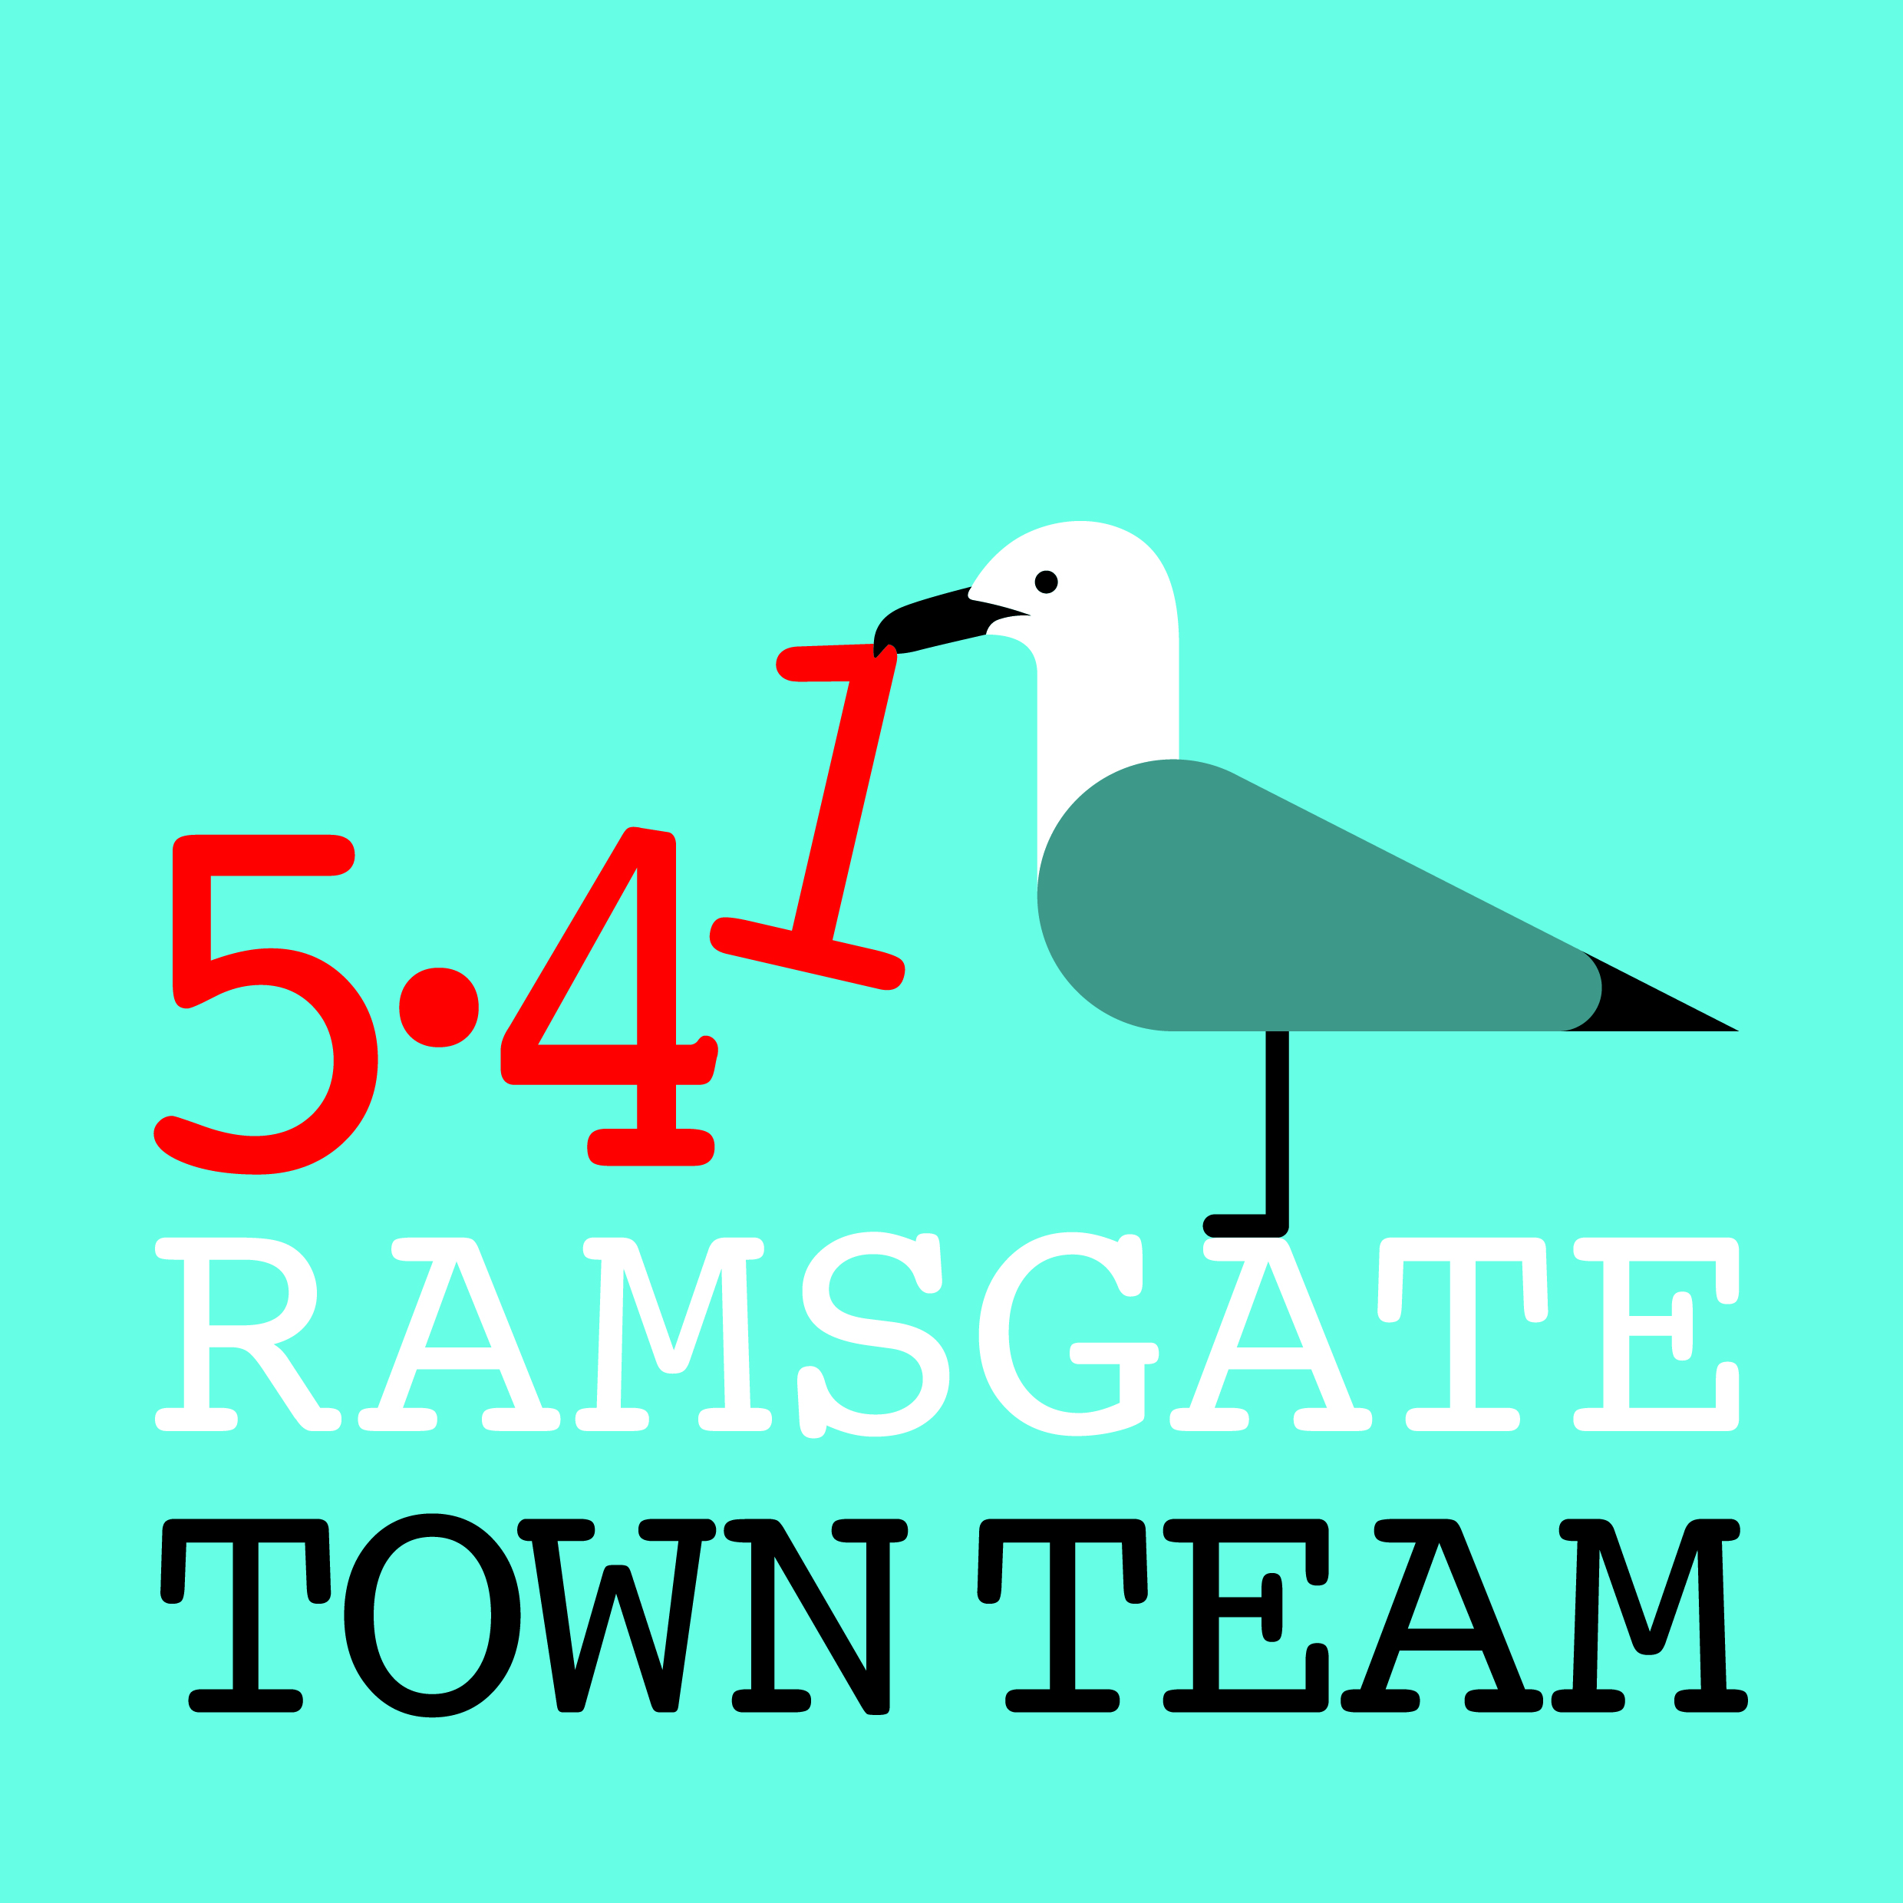
ANNUAL REPORT 2018-19
Ramsgate Town Team exists to help make Ramsgate a great place to live, work and visit. In 2018-19 the Town Team has been busy with a number of initiatives, including:
- Town Centre Working Group
Our Harbour Street Working Group is now a Town Centre group. We have worked to improve the streetscape and facilities in the town centre, including providing hanging baskets and fixtures for the Town Council’s new Christmas decorations in Harbour Street. We continue to offer small grants to retailers to improve their shopfronts within Conservation Area guidelines.
We have supported RTC’s efforts to get KCC to provide a permanent moveable bollard in Harbour St; progress is slow but a traffic survey to support this has now been completed.
We are concerned at continuing night-time problems in Harbour St, but since the Community Safety Manager’s secondment to another role our plans for a marshalling scheme have stalled.
We are currently working with TDC and the Coastal Communities Team on a proposal to the Government’s Future High Streets Fund which, if successful, would provide streetscape improvements, traffic calming measures and funding for us to buy up empty properties in Harbour St and High St for community use. Competition, however, is strong and the earliest that any funds would come through if we were successful would be summer 2020.
- Wayfinding Working Group
We are delighted that all but one of the monoliths and most of the finger posts commissioned last year from signage specialists Fitzpatrick Woolmer from Rochester are now finally in place. The final monolith, at Ramsgate Station, has suffered some delays as a result of the need for permissions from Network Rail and other interested parties, but should be installed shortly. The Town Team has contributed £17.5k towards the cost of these installations.
- Ramsgate Litter Forum
The Litter Forum, which met for the first time in March last year, now includes reps of some 15 voluntary organisations meeting 2-monthly with TDC & RTC to address litter and waste issues. Topics under review include the provision of street bins, management of seagull bags, information provided to householders new to the area and fly tipping.
The Town Team & Litter Forum co-ordinate several initiatives, including regular litter picks in town, on the seafront and in outlying areas like Pegwell and Newington, & the Ramsgate ROAD group whose nearly 400 members commit to picking up at least one piece of litter every day.
- Events Working Group
We have put on an Easter event and Spring, Summer and Winter parades with Arts in Ramsgate, Addington Street Group and Ramsgate Arts, and involved children from the junior and infant schools.
We hosted the Christmas Lights Switch On and saw the largest crowds ever for this winter event, working with Ramsgate Arts and Looping the Loop.
- Speaking Up for Ramsgate
The Town Team has responded to consultations on Thanet Parkway Station and the Local Plan, submitted written responses & spoken at PINS events on the proposed cargo hub at Manston.
We are represented on various local groups including the Heritage Action Zone, Neighbourhood Planning Group, Coastal Communities Team & Regeneration Alliance.
We have supported the work of groups including Addington St Group’s art outreach activities and the Ramsgate Heritage Trust’s successful Van Gogh funding proposal. We work closely with RTC and are grateful for their help in many areas, including maintaining our station planters and litter picking.
- Funding
Our contribution to the Wayfinding scheme has depleted the Town Team’s funds, so we are submitting bids for funding & sponsorship and launching 3 crowdfunding-type fundraisers.
The 5.41 scheme, a quirky nod to Ramsgate’s heritage, asks donors to commit £5.41 a month to our projects. With 100 members, we’d raise £6500 each year to improve our town. Please contact info@ramsgatetownteam.org.uk for a SO form or bank details to complete online.
With Thanet Community Lotto you can nominate a local organisation and win up to £25,000! To find out more and sign up visit www.thanetlotto.co.uk/support/ramsgate-town-team.
www.localgiving.org/charity/ramsgatetownteam is the third option to support us. The benefit of LocalGiving is that, although we are not a charity, we qualify for Gift Aid on one-off or regular donations through this site, increasing the amount raised at no extra cost to you!
We would be immensely grateful for any support members and friends can give to these initiatives, which will help us continue our work for the benefit of Ramsgate.
We’ve also launched a Ramsgate Funding Forum Facebook page to share funding information with local groups and encourage collaboration. It now has 74 members.
- Executive Committee Membership
Executive Committee: Executive Committee members for 2017-18 have been:
Rebekah Smith (Chair) Richard Styles Tricia Hartley (Secretary) Fiona Simmons Maria Gavin (Treasurer/ Membership) Madeline Wright Jo Hanchett Pat Makinson Sue Hall
We are sorry that our Treasurer, Maria Gavin, has recently retired from the Committee as a result of ill health. We are grateful for all her hard work and wish her a speedy return to better health. We are grateful to Pat Makinson for agreeing to take over the duties of Treasurer.
We are delighted that Becky Wing has volunteered to join the Committee. Becky was unanimously voted onto the Committee at its February meeting.
- Plans for 2018-19
Pugin Tiles Project: We have secured £3,000 from Heritage England for a project in which secondary school students will work with local ceramicists to study the Pugins’ work and design Pugin-style tiles to decorate the risers on Kent Steps. The Pugin Society are keen to include these in the Pugin Trail in future. We hope that to expand this project in future years, possibly including merchandise such as tiles and fabrics using the students’ designs.
Rainbow Steps revamp: It is 5 years since the artwork on the steps was done with schools and it is now in need of renewal. Children from Ramsgate infant & junior schools have submitted designs for display on the landings, which York Street Gallery will exhibit for a week in early April. We then expect to paint the railings in May.
Parades: To celebrate the new Rainbow Steps artwork we will be including a Rainbow Parade in our Easter Sunday celebrations this year, alongside the usual fun packed day. We have invited Looping the Loop to join in after their popular appearance at the Christmas Lights Switch On. We will also host our fourth Lantern Parade in December.
Van Gogh Summer project: We are supporting Ramsgate Society with their event on 15th June 2019 at Spencer Square which will include the unveiling of the Van Gogh bust, gifted to Ramsgate by renowned sculptor, Anthony Padgett. This will kick off a series of events and activities based around Van Gogh and his short stay in Ramsgate in the summer of 1786, including a book, Van Gogh trail, information stand (funded by Addington Street Community Group) and short film, working with local students, to highlight issues of mental health.
Welcome to Ramsgate planters: We have been awareded £3,200 from the Ramsgate Fund to install Victorian-style cast metal planters at key entrances to the town/ town centre. RTC are advising us to ensure these are located in places where they can easily be maintained.
Town Centre Refurbishment: We will be continuing our bollard-painting and planting activities over the summer and are always on the lookout for volunteers to help! Please let any member of the Committee know if you’re interested in helping.
Litter & Waste Management: New initiatives through the Litter Forum include:
- The Great Ramsgate Spring Clean (22nd March – 23rd April): as part of Keep Britain Tidy’s national initiative, we’re running clean-ups across Ramsgate, from the Ramsgate Society’s 3-hour ‘chine to chine’ seafront clean to 1-hour clean-ups of ‘grotspots’.
- Road Reps Ramsgate: we’re about to pilot this new initiative where volunteers become ‘Reps’ for their street, linking with TDC and RTC on litter & waste, ensuring new neighbours know about waste collections etc – like Neighbourhood Watch for rubbish!
- “No Ifs, No Butts” campaign: this is a new membership scheme launching during the Spring Clean month, encouraging pubs, bars, cafes, takeaways and betting shops to take responsibility for cleaning their frontages and removing cigarette litter.
- Bag it and Bin it Here: This is a pilot scheme where residents with a wheelie bin who are happy for bagged dog mess to be put in it can mark it with a yellow sticker (available at the Custom House).
We are grateful for the support of all the Town Team’s members and will be delighted to take on board any suggestions for our future work programme from members and friends.
A few visual highlights from Ramsgate Town Team’s year
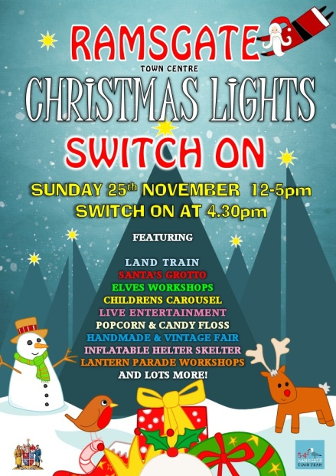  Christmas lights switch-on | Shopfront grants  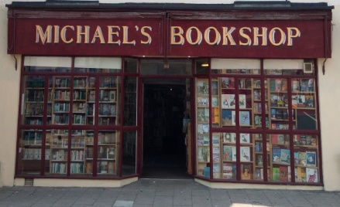  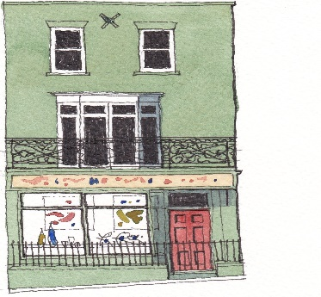 | 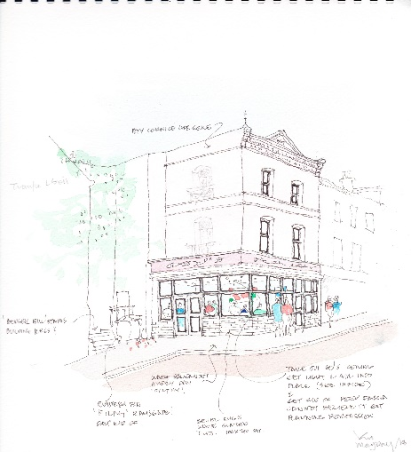  Harbour St improvement plans
Litter picking  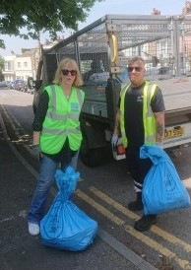 | New anti-litter initiatives    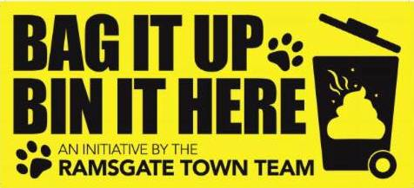 | Road Reps Ramsgate  